Sacred Heart of Jesus
Vehicle “Vaccines”
Sacred Heart Picnic Field
Saturday, December 12
Starts at 11:00 am

- Help Sacred Heart defray the costs of disinfecting our Church!
- Get the inside of your car disinfected and protected against germs, bacteria and viruses!
- This state-of-the art method and technology work to de-activate viruses for 30-60 days.
- 2-step process includes disinfecting and electro-statically applying microscopic technology that kills viruses.
- Your car will cleaned while you wait (about 15 minutes to apply & dry).
- Support Sacred Heart Parish while safeguarding your car!
- Suggested donation is $15 per car.
- Enjoy fellowship, community and a cup of coffee while you’re here!
- Bring a canned/non-perishable item for the Knights food basket drive!
- Call 610-837-7874 to sign-up for a time slot today!

One of our parishioner-owned businesses offers disinfecting and cleaning services for churches (including Sacred Heart!), office buildings and other institutions. While most of us spend time cleaning and disinfecting our hands and homes, are we as diligent with the surfaces in our cars? Lehigh Valley Disinfecting + Cleaning is offering this service exclusively for our parishioners and their friends and family.

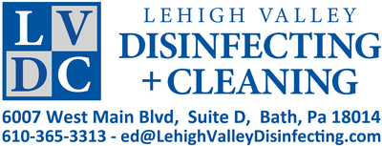

To sign up for an appointment or if you have any questions, please call the parish office at 610-837-7874 or fill out the info below and drop it into the collection basket or at the parish office.

Name: Phone #:_________________________________________

Preferred approximate time (circle one): 11:00 11:30 12:00 12:30 1:00

I can’t make it on Saturday the 12th, but would like to make a donation to help offset Sacred Heart Church disinfecting costs: $____________________________________

