Feed Your Family With Purpose
Sacred Heart Will Earn 5% Every time You Grocery Shop

The best way for parishioners to support this fundraiser is to use gift cards for things you always buy—like GROCERIES! With the new school year starting, here is a fantastic way to shop for school lunches and snacks. Make grocery shopping more convenient by purchasing a grocery gift card available in the lower level of the Burkhart Building (blue doors). Sacred Heart can earn a percentage from the sales of all gift cards. This is a TERRIFIC way to help support our Parish.

Please come in or call 610-837-6391 to purchase grocery or other available gift cards.
Office hours are Monday through Friday between 8:00 AM and 3:00 PM.

Grocery Gift Cards Available In Office

GIANT FOOD STORE WEGMANS WEIS

REDNER’S MARKETS AHART’S MARKET

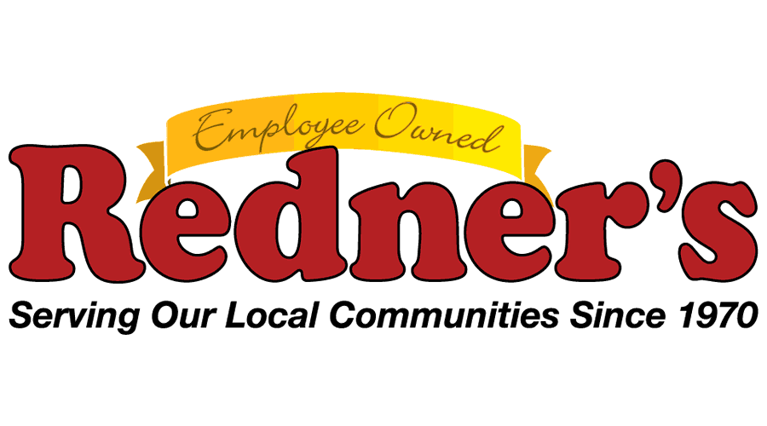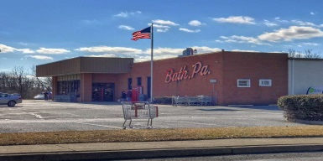

**Gift cards are always a great idea for Gift Giving**

(SEE REVERSE SIDE FOR ADDITIONAL AVAILABLE GIFT CARDS)
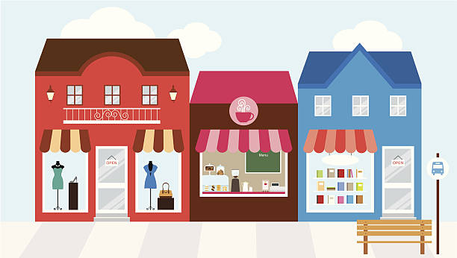
GREAT IDEAS FOR GIFT GIVING!
Sacred Heart can earn up to 15% from the sale of other retailer gift cards.
It’s never too early to start Christmas shopping! This is a wonderful way to help support Sacred Heart Parish. You can purchase or order specific gift cards at the office located in the lower level of the Burkhart Building (blue doors) between 8:00 AM and 3:00 PM, Monday through Friday or call 610-837-6391.
Stop by to say hello and see what we have on hand or check out the different gift cards that
you can order. For your convenience, we have a full list of all available gift cards Scrip offers.
Additional Available Gift Cards In Office
GIFT CARD | Percentage Earned | DENOMINATIONS
Amazon | 1.7% | $10/$25
Apple Store | 5% | $15/$25
Bed Bath & Beyond | 7% | $25
Best Buy | 4% | $25
Cabela’s | 10% | $25
CVS | 6% | $10/$25
Dunkin Donut | 3% | $10
Domino’s | 8% | $10
Home Depot | 4% | $25
Lands End | 15% | $25
Lowe’s | 4% | $25
Panera Bread | 8% | $10
Olive Garden & More | 8% | $25
Outback/Carrabba’s | 10% | $25
Red Robin | 8% | $25
Sheetz | 3% | $25
Subway | 4.5% | $10
Starbucks | 4.5% | $5/$10
Target | 2.5% | $25
WaWa | 1% | $25
Walmarts/Sam’s | 2.5% | $25
Wendy’s | 6.5% | $10
Visa Card - (No Activation Fee) | 1.25% | $50

